**PIZZA SELLS SQL QUERIES**

1. **KPI’S**
2. **Total Revenue**

SELECT SUM(total_price) AS Total_Revenue FROM pizza_sales

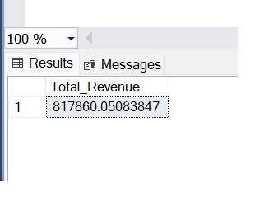

**2. Average Order Value**

SELECT SUM(total_price)/ COUNT(DISTINCT order_id) AS AVG_Order_Value

FROM pizza_sales

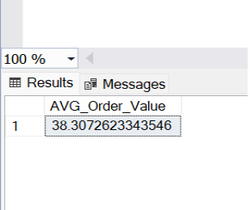

**3.Total Pizzas Sold**

SELECT SUM(quantity) AS Total_pizza_sold

FROM pizza_sales

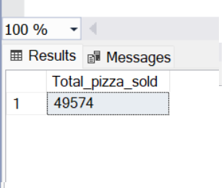

1. **Total Orders**

SELECT COUNT(Distinct order_id) AS Total_Orders

FROM pizza_sales

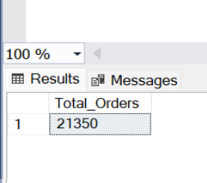

1. **Average Pizzas Per Order**

SELECT CAST(CAST(SUM(quantity) AS DECIMAL(10,2))/

CAST(COUNT(DISTINCT order_id) AS DECIMAL(10,2))

AS DECIMAL(10,2)) Avg_Pizzas_Per_Order FROM pizza_sales

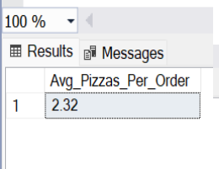

1. **Daily Trend for Total Orders**

SELECT DATENAME(DW ,order_date) AS Order_day , COUNT(DISTINCT order_id) AS Total_orders FROM pizza_sales GROUP BY DATENAME(DW ,order_date)

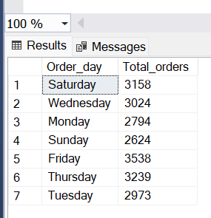

1. **Monthly Trend for Total Orders**

SELECT DATENAME(MONTH,order_date) AS Month_name , COUNT(DISTINCT order_id) AS Total_orders

FROM pizza_sales

GROUP BY DATENAME(MONTH,order_date)

ORDER BY Total_orders DESC

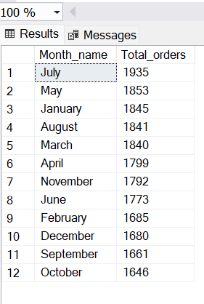

1. **% of Sales by Pizza Category**

SELECT pizza_category, sum(total_price) AS Total_sales,

sum(total_price) *100 / (SELECT sum(total_price) FROM pizza_sales) AS PCT_sales

FROM pizza_sales

GROUP BY pizza_category

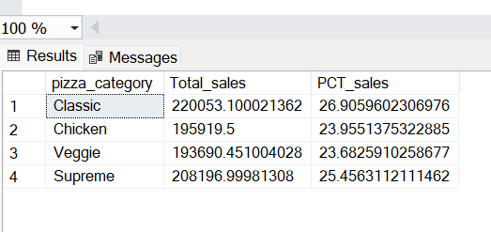

**Filter For first month :**

SELECT pizza_category, sum(total_price) AS Total_sales,

sum(total_price) *100 / (SELECT sum(total_price) FROM pizza_sales

WHERE MONTH(order_date)=1) AS PCT_sales

FROM pizza_sales

WHERE MONTH(order_date)=1

GROUP BY pizza_category

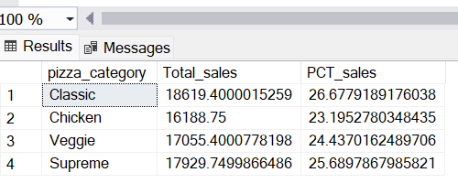

**E. % of Sales by Pizza Size**

SELECT pizza_size, sum(total_price) AS Total_sales,

sum(total_price) *100 / (SELECT sum(total_price) FROM pizza_sales) AS PCT

FROM pizza_sales

GROUP BY pizza_size

ORDER BY PCT DESC

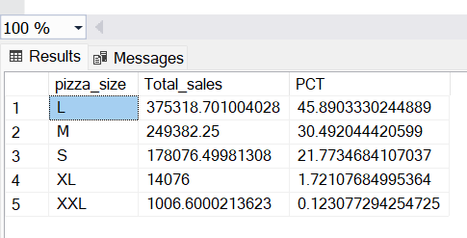

SELECT pizza_size, CAST(sum(total_price) AS DECIMAL(10,2))AS Total_sales,

CAST(sum(total_price) *100 / (SELECT sum(total_price) FROM pizza_sales) AS decimal(10,2) )AS PCT

FROM pizza_sales

GROUP BY pizza_size

ORDER BY PCT DESC

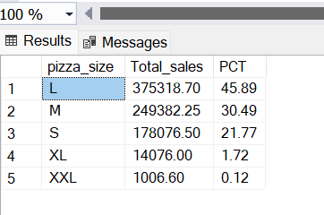

SELECT pizza_size, CAST(sum(total_price) AS DECIMAL(10,2)) AS Total_sales,

CAST(sum(total_price) *100 / (SELECT sum(total_price) FROM pizza_sales WHERE DATEPART(quarter , order_date)=1 )

AS decimal(10,2) ) AS PCT

FROM pizza_sales

WHERE DATEPART(quarter , order_date)=1

GROUP BY pizza_size

ORDER BY PCT DESC

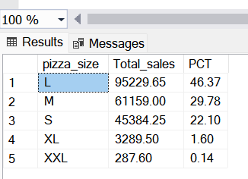

**F.Total Pizzas Sold by Pizza Category**

**G.Top 5 Pizzas by Revenue**

SELECT TOP 5 pizza_name, SUM(total_price) AS Total_Revenue FROM pizza_sales

GROUP BY pizza_name

ORDER BY Total_Revenue DESC

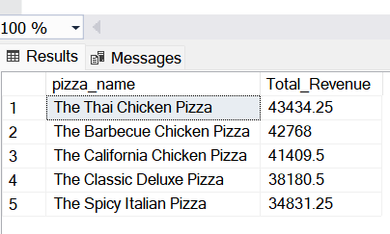

1. **Bottom 5 Pizzas by Revenue**

SELECT TOP 5 pizza_name, SUM(total_price) AS Total_Revenue FROM pizza_sales

GROUP BY pizza_name

ORDER BY Total_Revenue ASC

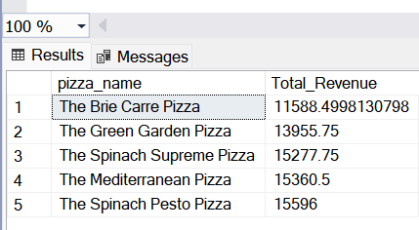

**I.Top 5 Pizzas by Quantity**

SELECT TOP 5 pizza_name, SUM(quantity) AS Total_Quantity FROM pizza_sales

GROUP BY pizza_name

ORDER BY Total_Quantity DESC

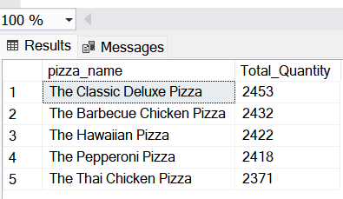

**J.Bottom 5 Pizzas by Quantity**

SELECT TOP 5 pizza_name, SUM(quantity) AS Total_Quantity FROM pizza_sales

GROUP BY pizza_name

ORDER BY Total_Quantity ASC

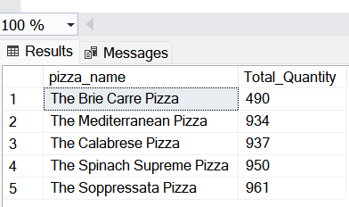

**K.Top 5 Pizzas by Total Orders**

SELECT TOP 5 pizza_name, COUNT(DISTINCT order_id) as Total_orders FROM pizza_sales

GROUP BY pizza_name

ORDER BY Total_orders DESC

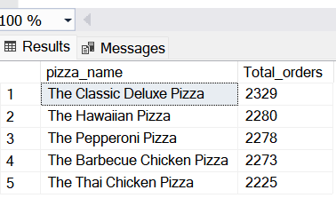

**L.Bottom 5 Pizzas by Total Orders**

SELECT TOP 5 pizza_name, COUNT(DISTINCT order_id) as Total_orders FROM pizza_sales

GROUP BY pizza_name

ORDER BY Total_orders ASC

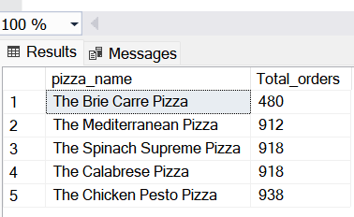

***NOTE***

If you want to apply the pizza_category or pizza_size filters to the above queries you can use WHERE clause. Follow some of below examples

SELECT Top 5 pizza_name, COUNT(DISTINCT order_id) AS Total_Orders

FROM pizza_sales

WHERE pizza_category = 'Classic'

GROUP BY pizza_name

ORDER BY Total_Orders ASC